**Practical No:-1**

**a) Description about Wikipedia and its features:-**

A)Description of Wikipedia are as follow:-

1)Wikipedia is a free, multilingual open-collaborative online encyclopedia created and maintained by a community of volunteer editors using a wiki-based editing system. Featuring no advertisements, it is hosted by the Wikimedia Foundation, an American non-profit organization funded primarily through donations.

2)Wikipedia is a free, open content online en-cyclopedia created through the collaborative effort of a community of users known as Wiki-pedians. Anyone registered on the site can create an article for publication; registration is not required to edit articles. The site's name comes from wiki, a server program that enables anyone to edit Web site content through their Web browser.

3)Wikipedia was launched by Jimmy Wales and Larry Sanger. Sanger coined its name as a portmanteau of "wiki" and "encyclopedia". It was initially an English-language encyclopedia, but versions in other languages were quickly developed.

4)Wikipedia has been criticized for its uneven accuracy and for exhibiting systemic bias, including gender bias, with the majority of editors being male. Edit-a-thons have been held to encourage female editors and increase the coverage of women's topics.

B)Features of Wikipedia are as follow:-

1) Creation of page, you can set your title and can add your own texts, no need of coding just type and format text like an email ,when you done click on submit and its ready to view for everyone.

2) You can edit a public page if you find an outdated data , you can open editing screen and edit and then click on submit and

changes are made.

3)Links can be created between pages you can simply add brackets around another Wiki page's title (e.g. [ Example Page Title ]) to

automatically link to that page.

**b) Creating Account on Wikipedia:-**

Step 1:-Open the wiki-pedia website and click on the "Create Account" on the upper right corner as shown in red box.

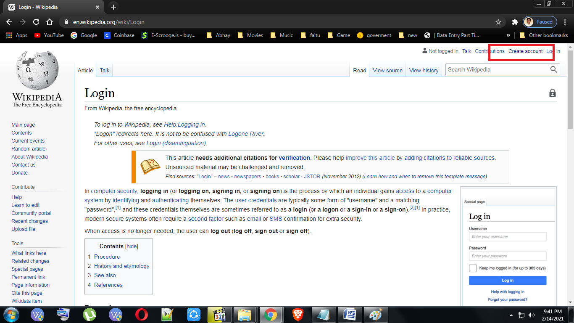

Step 2:- Fill in the required details and click on the “Create your account” button.

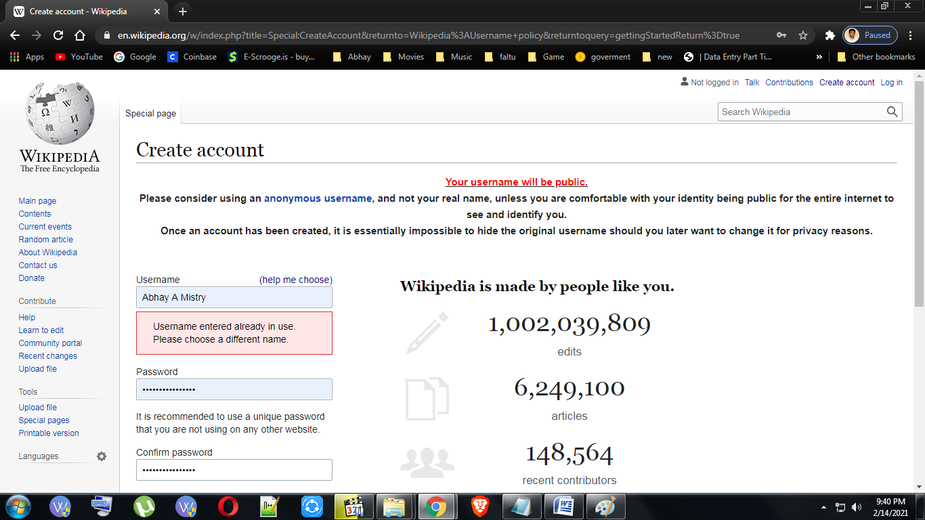

After clicking the button the account will be created and this page will display.

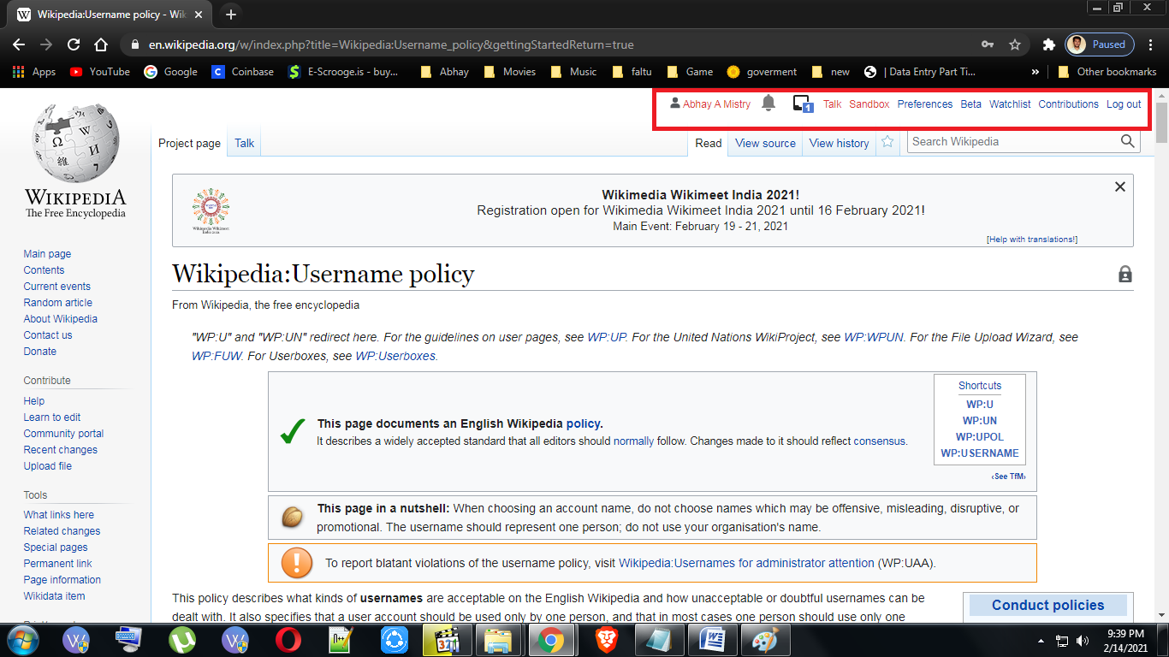

c) Creating your page on Wikipedia:-

Step 1:-After Login ,click on your username on the upper right corner.

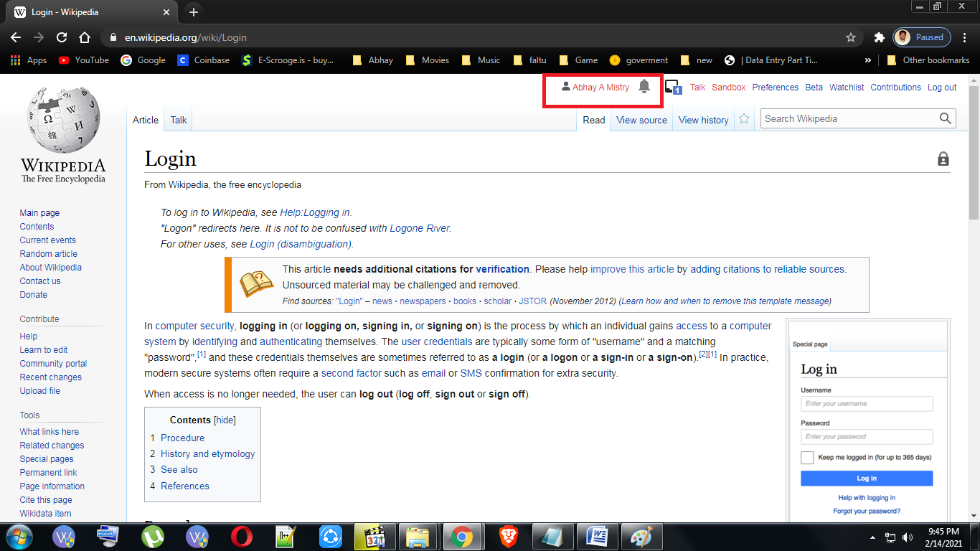

Step 2:- Click on "create source" to start creating the page.

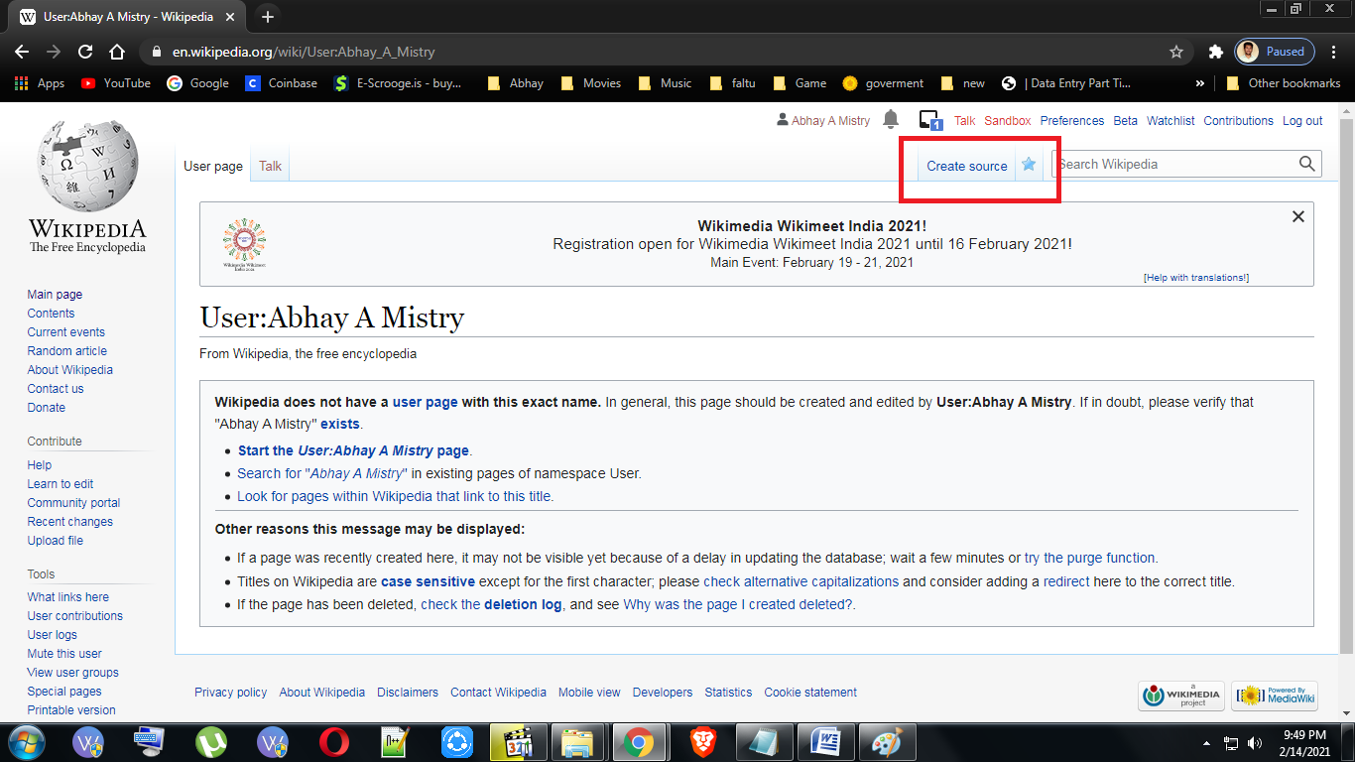

Step 3:- Insert your data for the page you want to create in the given text window . After inserting the data, scroll down and click on the show preview option this will appear.

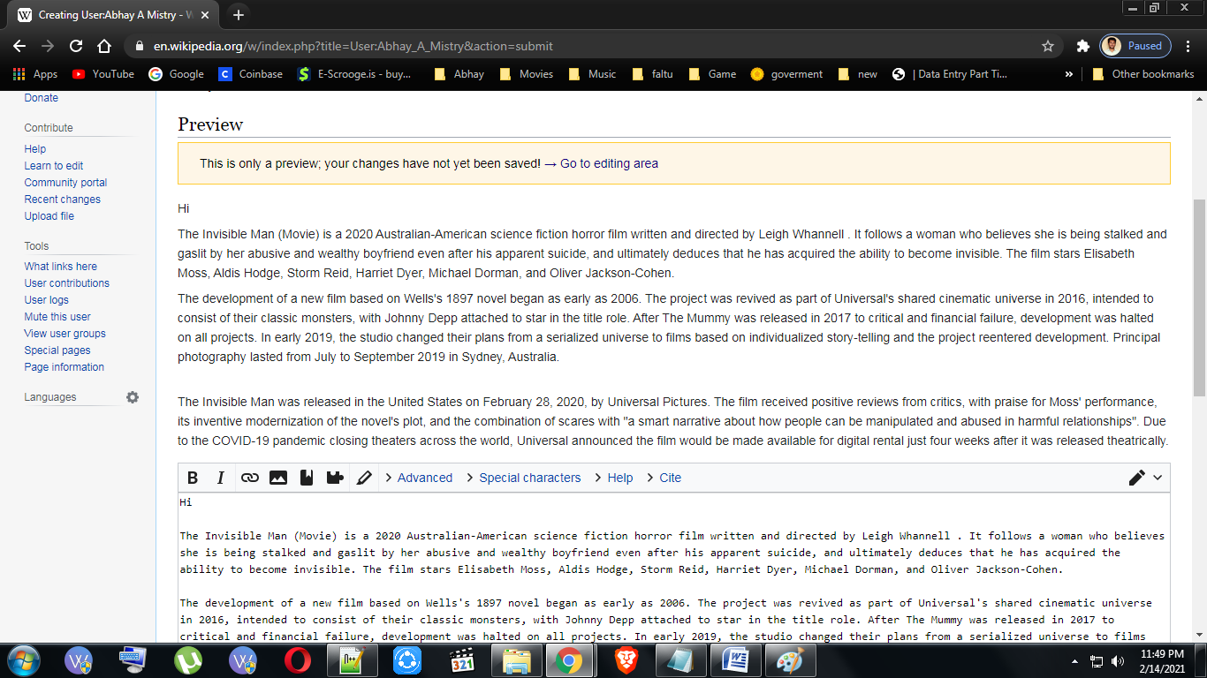

Step 5:- Click on the "Publish page" button to publish or create the page. Then your page will be published as shown below.

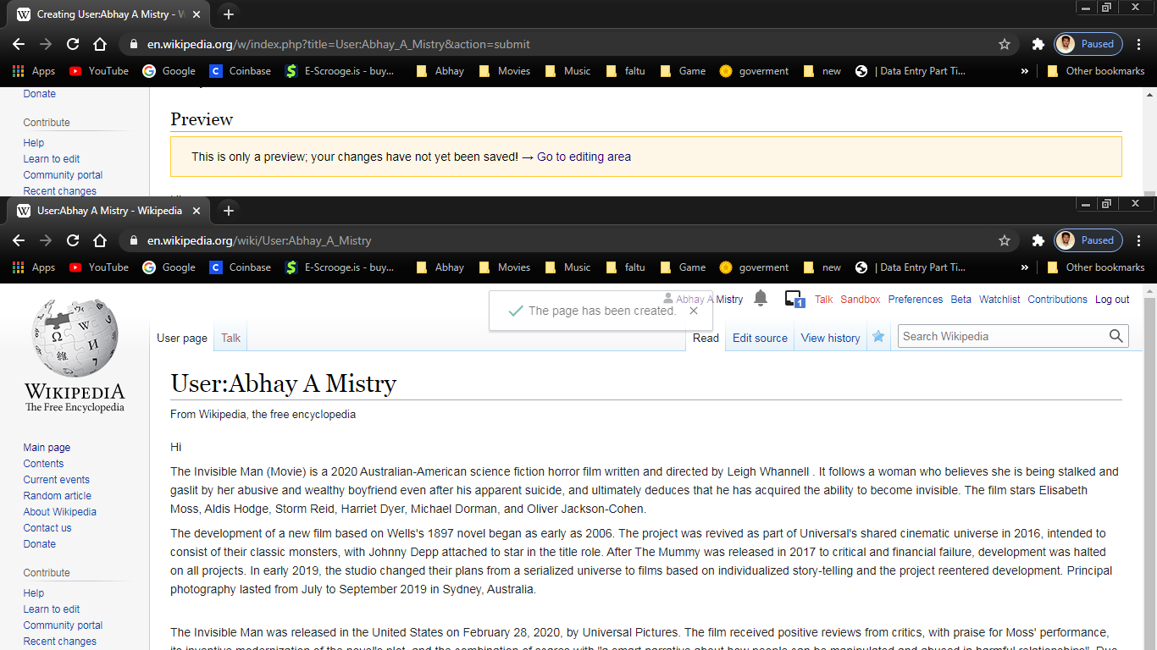

d) Editing your page on Wikipedia:-

Step 1:- Click on "Edit source".

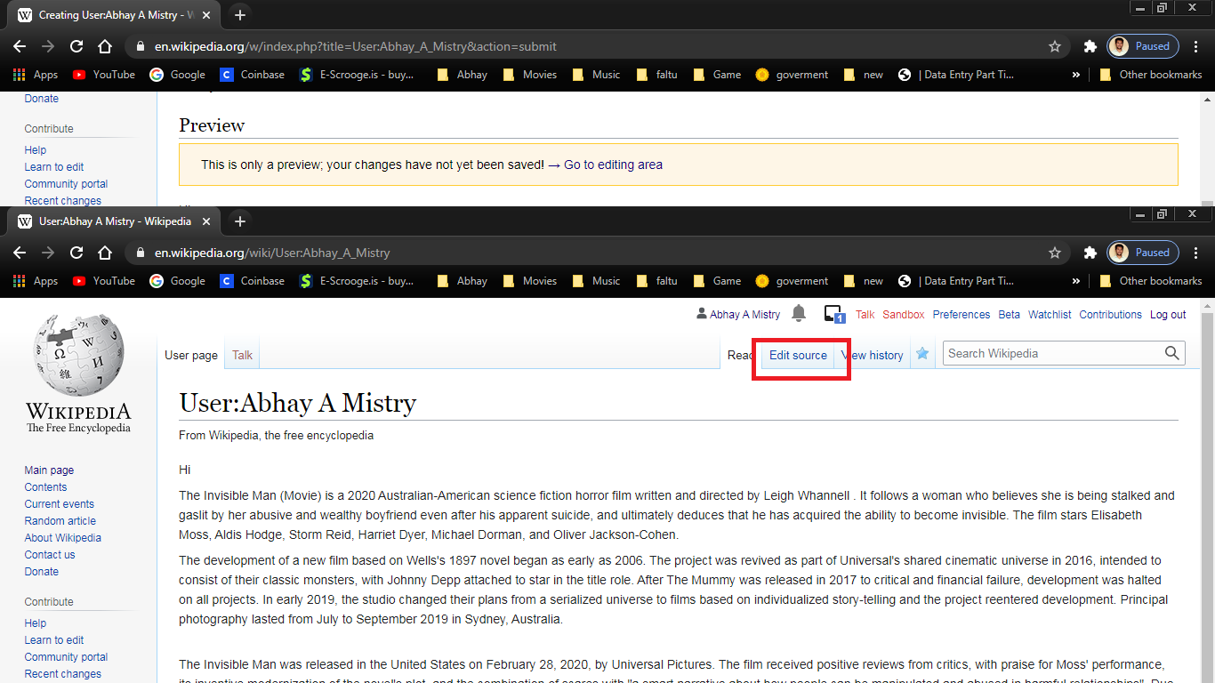

Step 2:- Make the required changes and click on the "Publish changes" button to finish the edit.

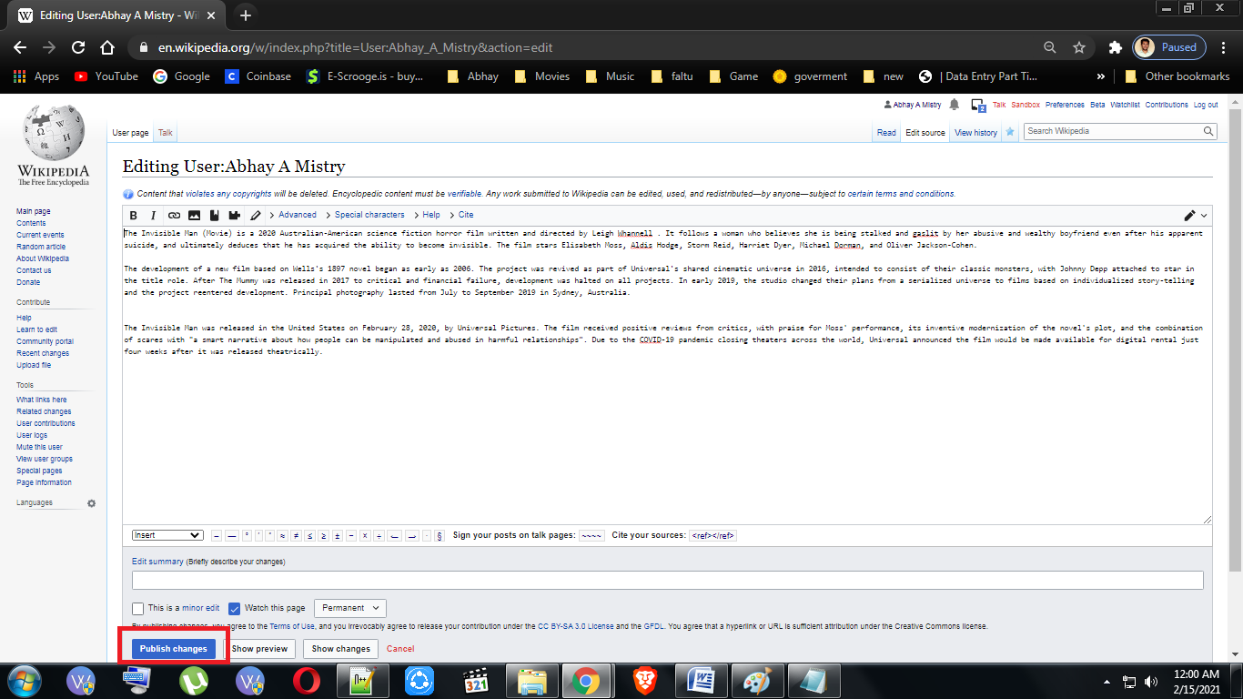

As we can see the changes has been made.

